**11. ReactJS-HOL**

Create a React Application “eventexamplesapp” to handle various events of the form elements in HTML.

1. Create “Increment” button to increase the value of the counter and “Decrement” button to decrease the value of the counter. The “Increase” button should invoke multiple methods.
   1. To increment the value
   2. Say Hello followed by a static message.
2. Create a button “Say Welcome” which invokes the function which takes “welcome” as an argument
3. Create a button which invokes a synthetic event “OnPress” that display “I was clicked”
4. Create a “CurrencyConvertor” component which will convert the Indian Rupees to Euro when the Convert button is clicked.

Handle the Click event of the button to invoke the handleSubmit event and handle the conversion of the euro to rupees.

**Code**

App.js

import React, { useState } from 'react';

function App() {

  // Counter state

  const [count, setCount] = useState(0);

  // Currency state

  const [inr, setInr] = useState('');

  const [euro, setEuro] = useState(null);

  // 1.Multiple methods on increment

  const handleIncrement = () => {

    setCount(count + 1);

    sayHello();

  };

  const sayHello = () => {

    alert("Hello! Member!");

  };

  const handleDecrement = () => {

    setCount(count - 1);

  };

//2.welcome method

  const sayMessage = (msg) => {

    alert(msg);

  };

//3.clickButton

  const handleSyntheticClick = () => {

    alert("I was clicked");

  };

//4.convert INR to EURO

  const handleCurrencyConvert = (e) => {

    e.preventDefault();

    const rupees = parseFloat(inr);

    if (isNaN(rupees)) {

      alert("Please enter a valid amount in INR");

      return;

    }

    const euroRate = 0.011; // Approx rate

    setEuro((rupees * euroRate).toFixed(2));

  };

  return (

    <div style={{ padding: '30px', fontFamily: 'Arial' }}>

      <p>Count: {count}</p>

      <button onClick={handleIncrement}>Increment</button><br></br>

      <button onClick={handleDecrement}>Decrement</button>

      <hr />

        <button onClick={() => sayMessage("Welcome")}>Say welcome</button>

      <hr />

      <button onClick={handleSyntheticClick}>Click on me</button>

      <hr />

      <h2 style={{ color: 'green' }}>Currency Converter!!!</h2>

      <h5>INR to EURO</h5>

      <form onSubmit={handleCurrencyConvert}>

        <input

          type="number"

          value={inr}

          onChange={(e) => setInr(e.target.value)}

          placeholder="Enter INR amount"

          style={{ padding: '10px', fontSize: '16px' }}   />

        <button type="submit" style={{ marginLeft: '10px' }}>Submit</button>

      </form>

      {euro && (

        <p>Converted Amount: <strong>€ {euro}</strong></p>

      )}

    </div>  );}

export default App;

Output:

  // 1.Multiple methods on increment

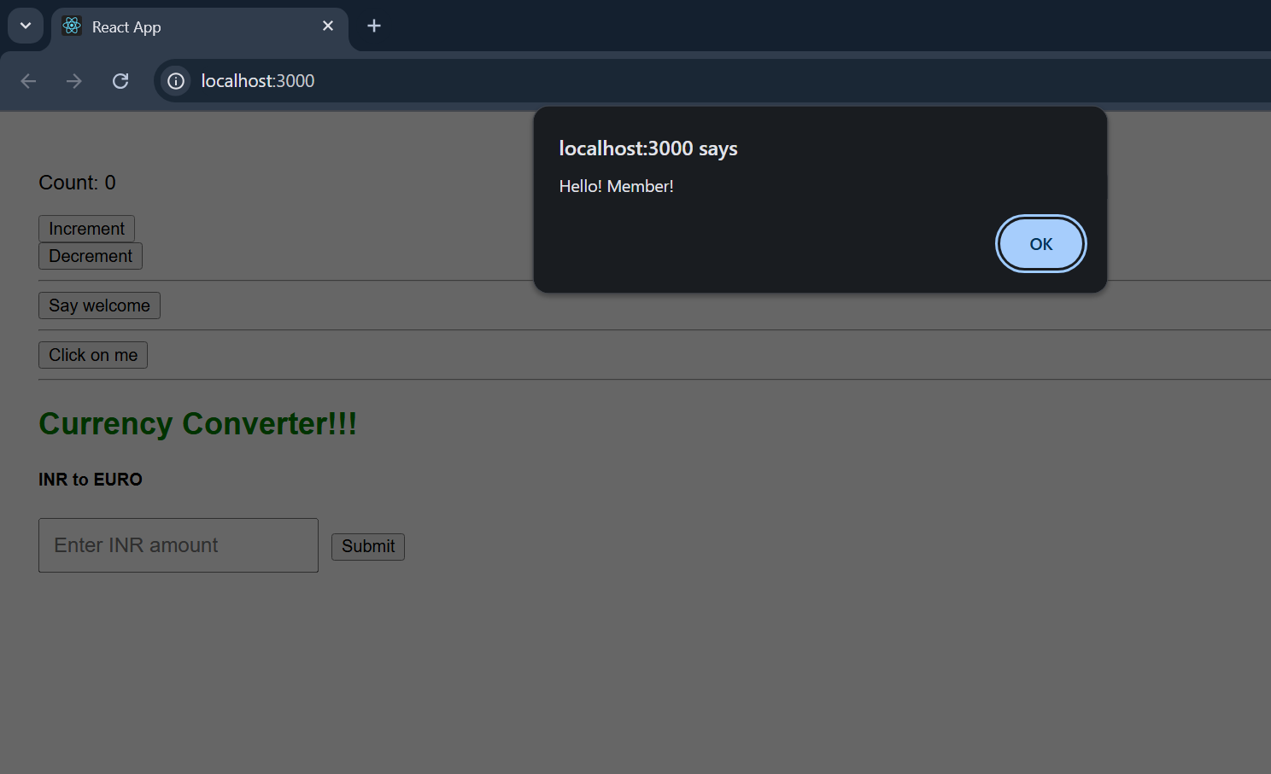

//increment count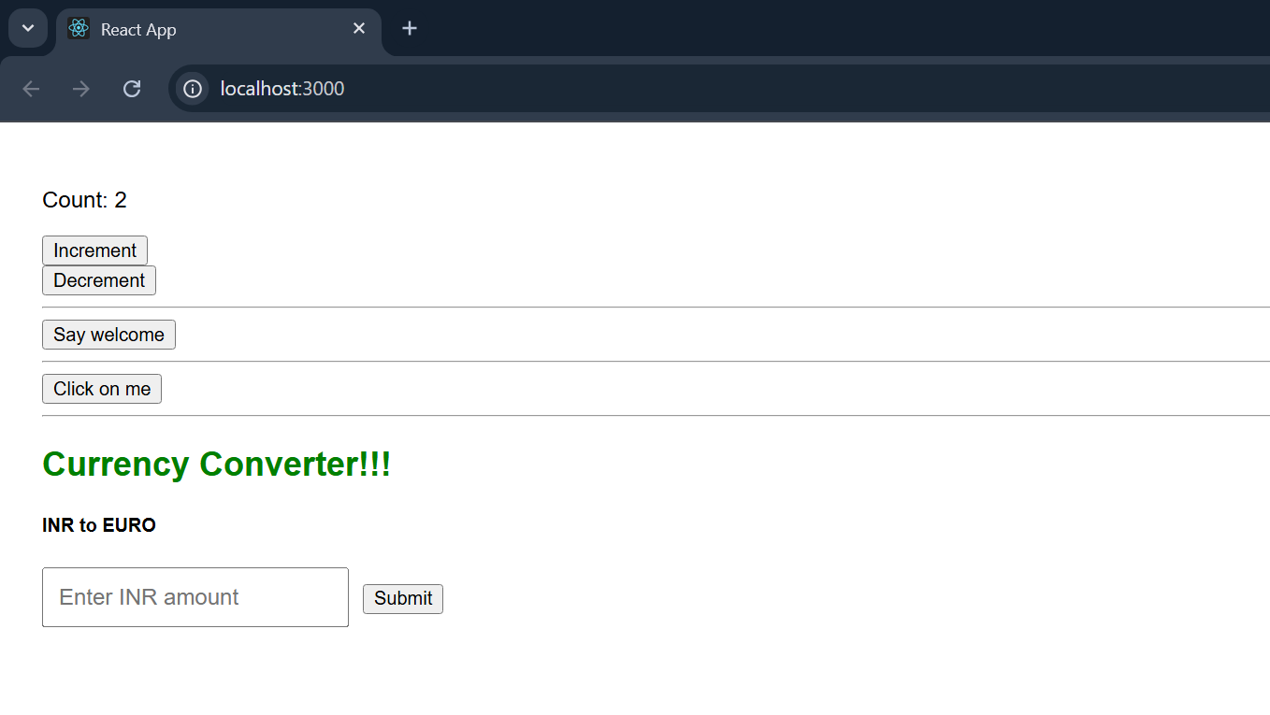

//2.welcome method

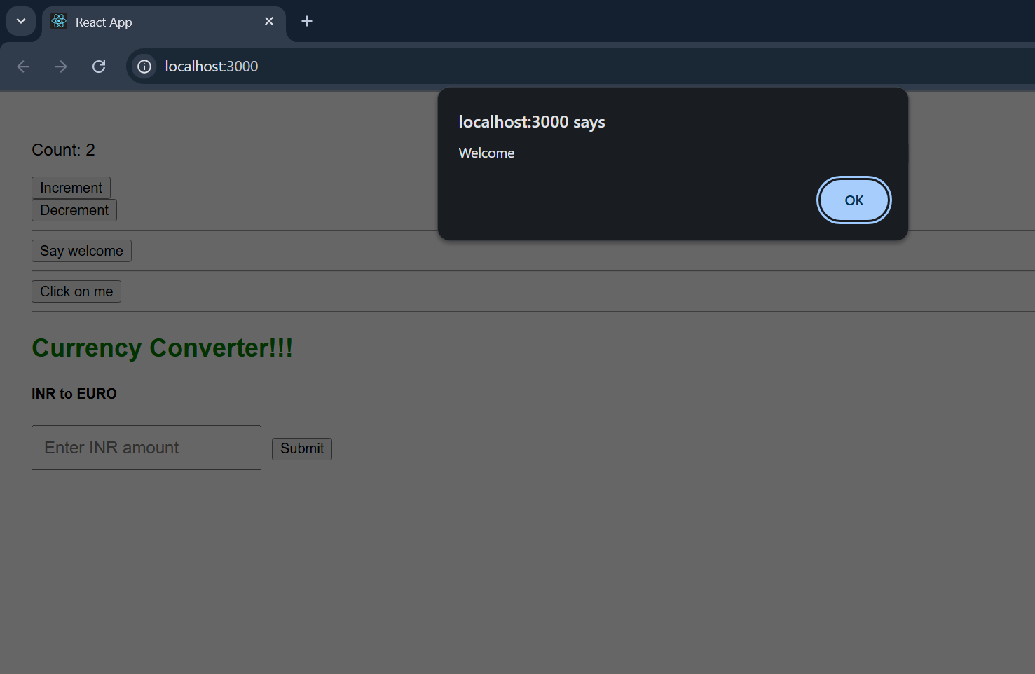

//3.clickButton

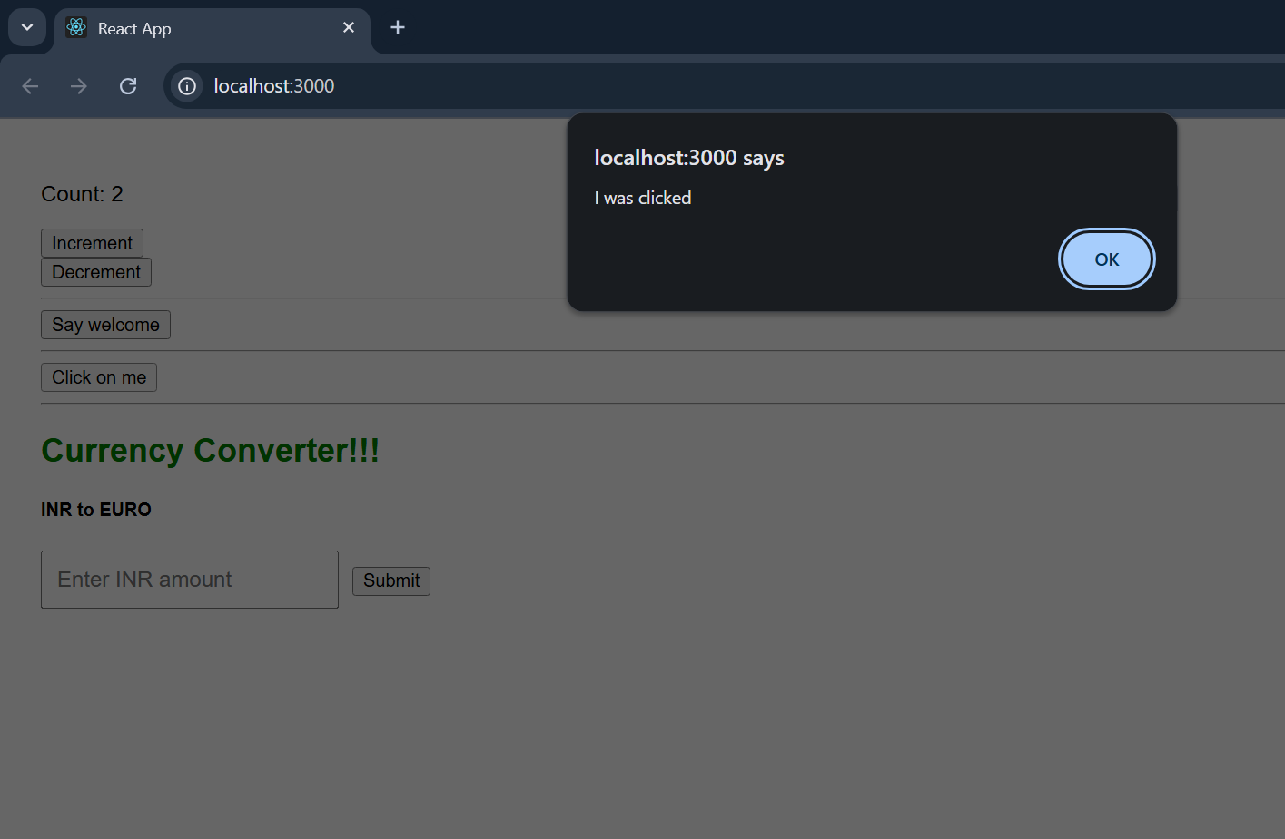

//4.convert INR to EURO

